**Project Write-up**

DESCRIPTION

**Project Objective:**

As a developer, write a program to read, write, and append to a file.

**Background of the problem statement:**

As a developer, write a Java code to read, write, and append to a file.

**FileHandling:**

**package File_Handling;**

**import java.io.BufferedReader;**

**import java.io.BufferedWriter;**

**import java.io.File;**

**import java.io.FileReader;**

**import java.io.FileWriter;**

**import java.io.IOException;**

**import java.util.Scanner;**

**import java.util.StringTokenizer;**

**public class EmployeeRecordFileHandling {**

**public static void main(String[] args) {**

**Scanner strInput = new Scanner(System.in);**

**String choice,cont = "y";**

**while( cont.equalsIgnoreCase("y") ) {**

**System.out.println("\tEmployee Information System\n\n");**

**System.out.println("1 ===> Add New Employee Record ");**

**System.out.println("2 ===> View All Employee Record ");**

**System.out.println("3 ===> Delete Employee Record ");**

**System.out.println("4 ===> Search Specific Record ");**

**System.out.println("5 ===> Update Specific Record ");**

**System.out.print("\n\n");**

**System.out.println("Enter your choice: ");**

**choice = strInput.nextLine();**

**if( choice.equals("1") ) {**

**try {**

**AddRecord();**

**} catch (IOException e) {**

**// TODO Auto-generated catch block**

**e.printStackTrace();**

**}**

**} else if( choice.equals("2") ) {**

**try {**

**ViewAllRecord();**

**} catch (IOException e) {**

**// TODO Auto-generated catch block**

**e.printStackTrace();**

**}**

**}**

**else if( choice.equals("3") ) {**

**try {**

**DeleteRecordByID();**

**} catch (IOException e) {**

**// TODO Auto-generated catch block**

**e.printStackTrace();**

**}**

**}**

**else if( choice.equals("4") ) {**

**try {**

**SearchRecordbyID();**

**} catch (IOException e) {**

**// TODO Auto-generated catch block**

**e.printStackTrace();**

**}**

**}**

**else if( choice.equals("5") ) {**

**try {**

**updateRecordbyID();**

**} catch (IOException e) {**

**// TODO Auto-generated catch block**

**e.printStackTrace();**

**}**

**}**

**System.out.println("Do you want to continue? Y/N");**

**cont = strInput.nextLine();**

**}**

**}**

**public static void AddRecord() throws IOException {**

**BufferedWriter bw = new BufferedWriter(new FileWriter("records.txt",true) );**

**Scanner strInput = new Scanner(System.in);**

**String ID, name, age, addr;**

**System.out.print("Enter the Employee ID: ");**

**ID = strInput.nextLine();**

**System.out.print("Enter the Employee Name: ");**

**name = strInput.nextLine();**

**System.out.print("Enter the Employee Age: ");**

**age = strInput.nextLine();**

**System.out.print("Enter the Employee Address: ");**

**addr = strInput.nextLine();**

**bw.write(ID+","+name+","+age+","+addr);**

**bw.flush();**

**bw.newLine();**

**bw.close();**

**}**

**public static void ViewAllRecord() throws IOException {**

**BufferedReader br = new BufferedReader( new FileReader("records.txt") );**

**String record;**

**System.out.println(" ---------------------------------------- ");**

**System.out.println("| ID Name Age Address |");**

**System.out.println(" ---------------------------------------- ");**

**while( ( record = br.readLine() ) != null ) {**

**StringTokenizer st = new StringTokenizer(record,",");**

**System.out.println(" "+st.nextToken()+" " + st.nextToken()+" "**

**+ st.nextToken()+" " + st.nextToken());**

**}**

**System.out.println(" ----------------------------------------- ");**

**br.close();**

**}**

**public static void DeleteRecordByID() throws IOException {**

**Scanner strInput = new Scanner(System.in);**

**String ID, record;**

**File tempDB = new File("records_temp.txt");**

**File db = new File("records.txt");**

**BufferedReader br = new BufferedReader( new FileReader( db ) );**

**BufferedWriter bw = new BufferedWriter( new FileWriter( tempDB ) );**

**System.out.println("\t\t Delete Employee Record\n");**

**System.out.println("Enter the Employee ID: ");**

**ID = strInput.nextLine();**

**while( ( record = br.readLine() ) != null ) {**

**if( record.contains(ID) )**

**continue;**

**bw.write(record);**

**bw.flush();**

**bw.newLine();**

**}**

**br.close();**

**bw.close();**

**db.delete();**

**tempDB.renameTo(db);**

**}**

**public static void SearchRecordbyID() throws IOException {**

**String ID,record;**

**Scanner strInput = new Scanner(System.in);**

**BufferedReader br =new BufferedReader(new FileReader("records.txt"));**

**System.out.println("\t\t Search Employee Record\n");**

**System.out.println("Enter the Employee ID: ");**

**ID = strInput.nextLine();**

**System.out.println(" ------------------------------------------- ");**

**System.out.println("| ID Name Age Address |");**

**System.out.println(" ------------------------------------------- ");**

**while( ( record = br.readLine() ) != null ) {**

**StringTokenizer st = new StringTokenizer(record,",");**

**if( record.contains(ID) ) {**

**System.out.println("| "+st.nextToken()+" "+st.nextToken()+" " +st.nextToken()+" "+st.nextToken()+" |");**

**}**

**}**

**System.out.println(" -------------------------------------------- ");**

**br.close();**

**}**

**public static void updateRecordbyID() throws IOException {**

**String newName, newAge, newAddr, record, ID,record2;**

**File db = new File("records.txt");**

**File tempDB = new File("records_temp.txt");**

**BufferedReader br = new BufferedReader( new FileReader(db) );**

**BufferedWriter bw = new BufferedWriter( new FileWriter(tempDB) );**

**Scanner strInput = new Scanner(System.in);**

**System.out.println("\t\t Update Employee Record\n\n");**

**System.out.println("Enter the Employee ID: ");**

**ID = strInput.nextLine();**

**System.out.println(" -------------------------------------------- ");**

**System.out.println("| ID Name Age Address|");**

**System.out.println(" -------------------------------------------- ");**

**while( ( record = br.readLine() ) != null ) {**

**StringTokenizer st = new StringTokenizer(record,",");**

**if( record.contains(ID) ) {**

**System.out.println("| "+st.nextToken()+" "+st.nextToken()+" " +st.nextToken()+" "+st.nextToken()+" |");**

**}**

**}**

**System.out.println(" -------------------------------------------- ");**

**br.close();**

**System.out.println("Enter the new Name: ");**

**newName = strInput.nextLine();**

**System.out.println("Enter the new Age: ");**

**newAge = strInput.nextLine();**

**System.out.println("Enter the new Address: ");**

**newAddr = strInput.nextLine();**

**BufferedReader br2 = new BufferedReader( new FileReader(db) );**

**while( (record2 = br2.readLine() ) != null ) {**

**if(record2.contains(ID)) {**

**bw.write(ID+","+newName+","+newAge+","+newAddr);**

**} else {**

**bw.write(record2);**

**}**

**bw.flush();**

**bw.newLine();**

**}**

**bw.close();**

**br2.close();**

**db.delete();**

**boolean success = tempDB.renameTo(db);**

**System.out.println(success);**

**}**

**}**

**Output:**

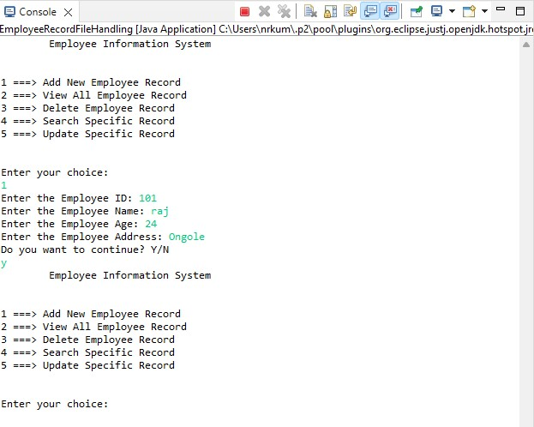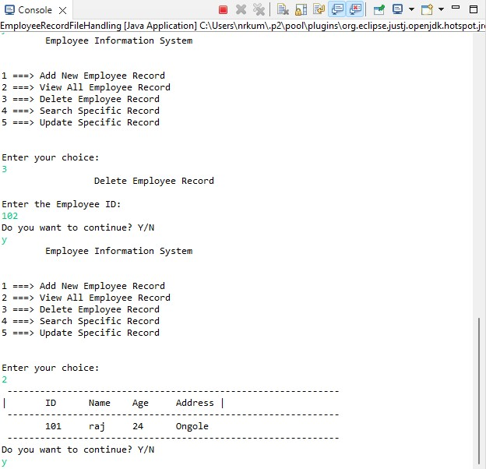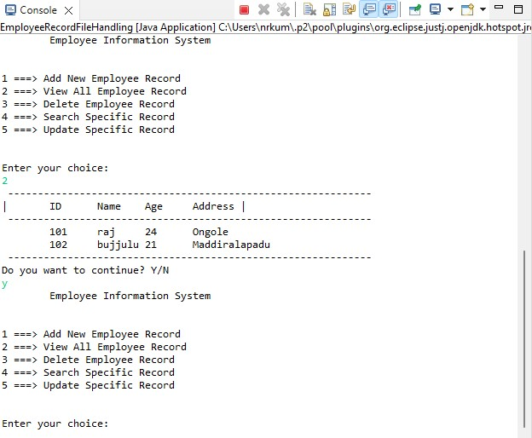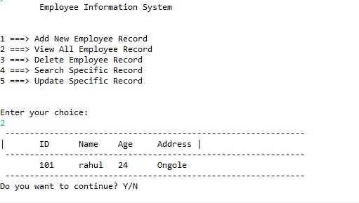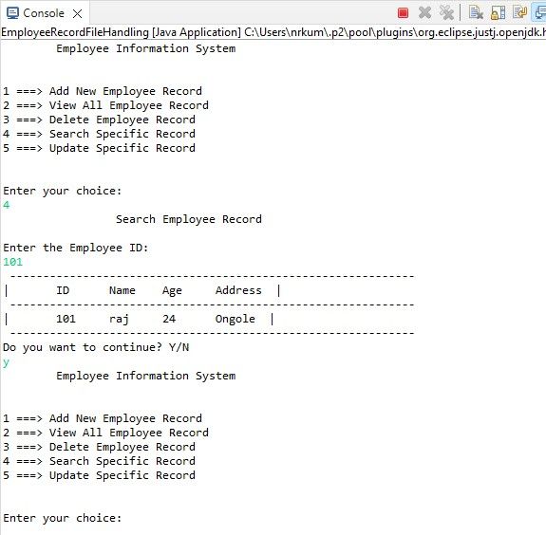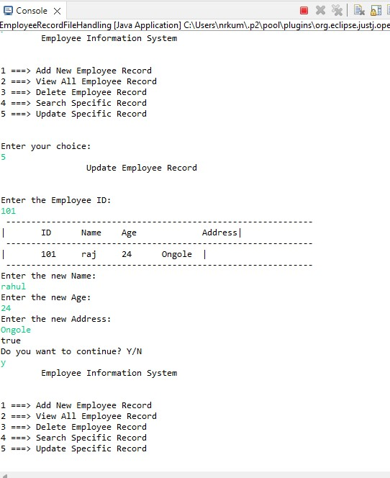

Pushing the code to your GitHub repositories

* Open your command prompt and navigate to the folder where you have created your files.

**cd <folder path>**

* Initialize your repository using the following command:

**git init**

* Add all the files to your git repository using the following command:

**git add .**

* Commit the changes using the following command:

**git commit . -m “Changes have been committed.”**

* Push the files to the folder you initially created using the following command:

**git push -u origin master**